**Worksheet**

**EXPERIMENT – 7**

***YASH GUPTA***

***20BCS5009***

# Aim:

Create a service ChatBot that responds with relevant data in a conversation for Educational institutions.

# Requirements:

PC with internet connectivity, Python 3.7

## Output:

## 1st screen 🡪

## 2nd screen 🡪 Program

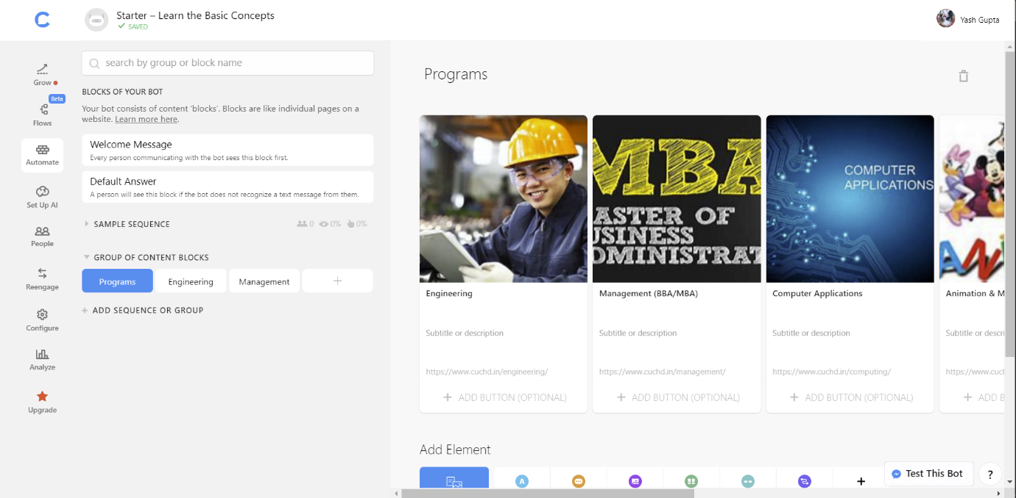

## 3rd screen 🡪 Engineering

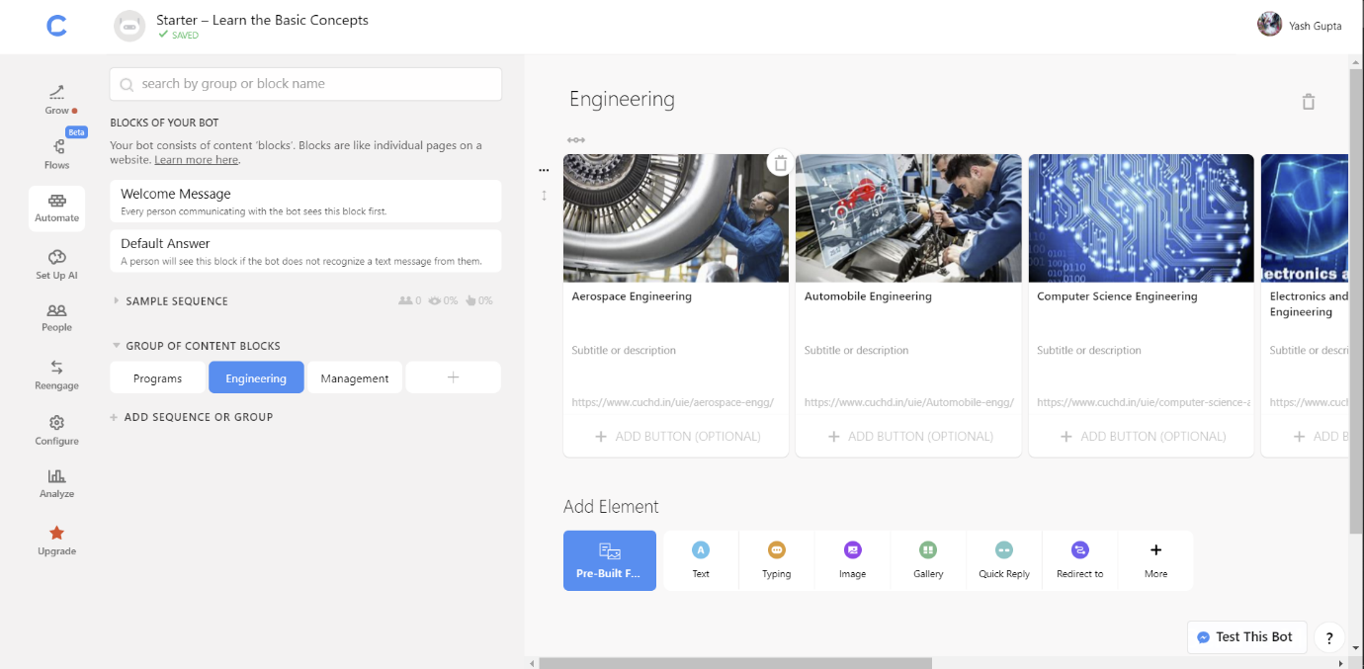

## 4th screen 🡪 Management

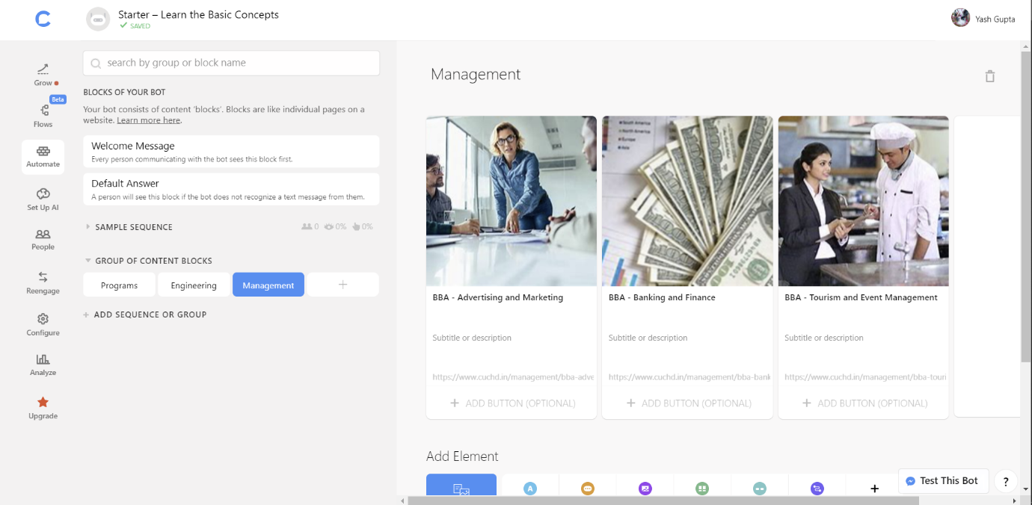

## 5th END screen 🡪

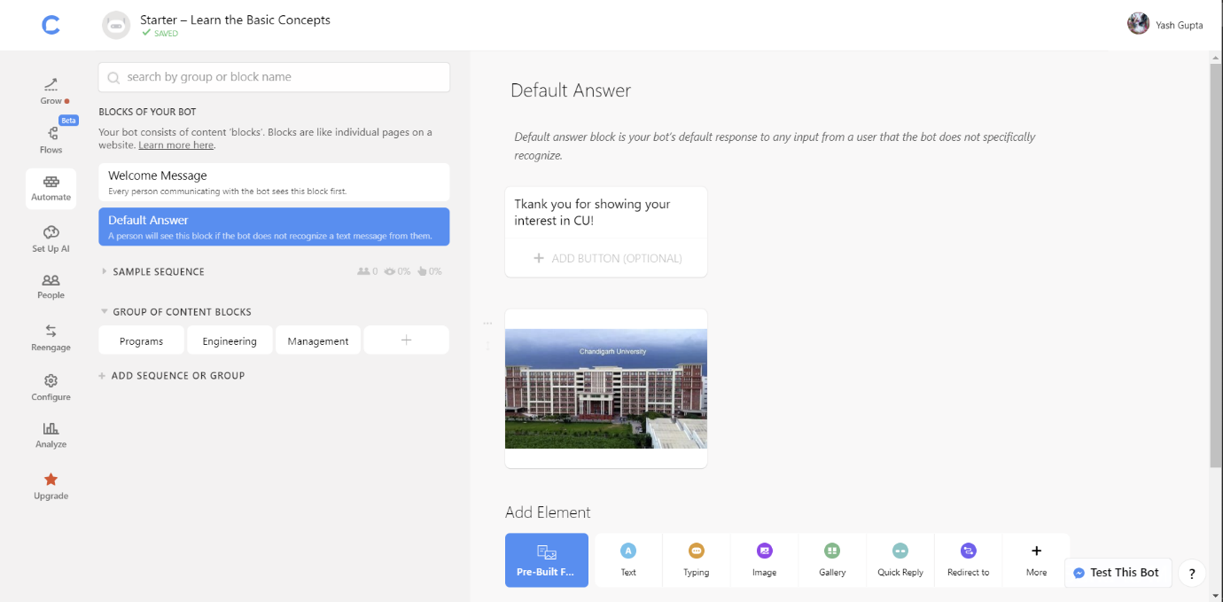

## ***Error occurrence 🡪***

## 6th screen 🡪 AI

